Document No: | [Subject] | Issue: | [Status] | Effective date: | [Publish Date]

Document Title:
DCO User Manual
Summary / Scope:
This document describes the I/O and functionality of the Digitally Controlled Oscillator (DCO) board. It will show the relevant pinouts and connections required to interface with the Xmega Xplained development board as well as the calculations and processes required to get the basics of the board operating.
Reason for Issue / Nature of Change:
Issue | Date | Details – reason for issue / nature of change
01
02
03

AUTHORISATION
 | Name: | Job title: |  | Signed:
Author: | Benjamin Bolton | Click to enter text
Reviewer: |  | Click to enter text
Approver / Owner: |  | Click to enter text
Authorisation details required irrespective of document approval process applied. |  |  |  | Electronic signatures required only where SharePoint approval workflows are not being used.

Copyright Statement
© 2026 Renishaw plc

This document is the property of Renishaw plc and the information contained herein is confidential. The contents of the document must not be reproduced or disclosed wholly or in part, or used for purposes other than that for which it has been supplied, without the prior written permission of Renishaw plc, or, if it has been furnished under a contract with another party, as expressly authorised under that contract.
Table of Contents
1 System Architecture 3
1.1 Module Overview 3
1.2 Analogue Outputs 4
2 Theory of Operation 4
2.1 Triangle and PWM Signals 4
2.2 Sin Wave Signal 5
2.3 Operational Overview 6
3 Interfacing Guide 6
3.1 Capacitance Selection 6
3.2 Digipot Interface 7
3.3 Frequency Measuring 9
3.4 Rotary Encoder Interface 9
3.5 Multiplexer Interface 9
3.6 Extra functionality 10
3.7 Default features 10
4 Pinout & Pin Descriptions 10
4.1 Capacitor Selection Pins 10
4.2 Digipot Pins 11
4.3 Frequency Measurement Pins 11
4.4 Rotary Encoder Pins 11
4.5 Multiplexer Pins 12
4.6 LCD Pins 12
4.7 Switch Pins 12
4.8 Extra Pins 13
5 Test Points 13
6 Appendix 14
6.1 Appendix A 14
6.2 Appendix B 15
6.3 Appendix C 17
6.4 Appendix D 18
6.5 Appendix E 19

System Architecture

Module Overview
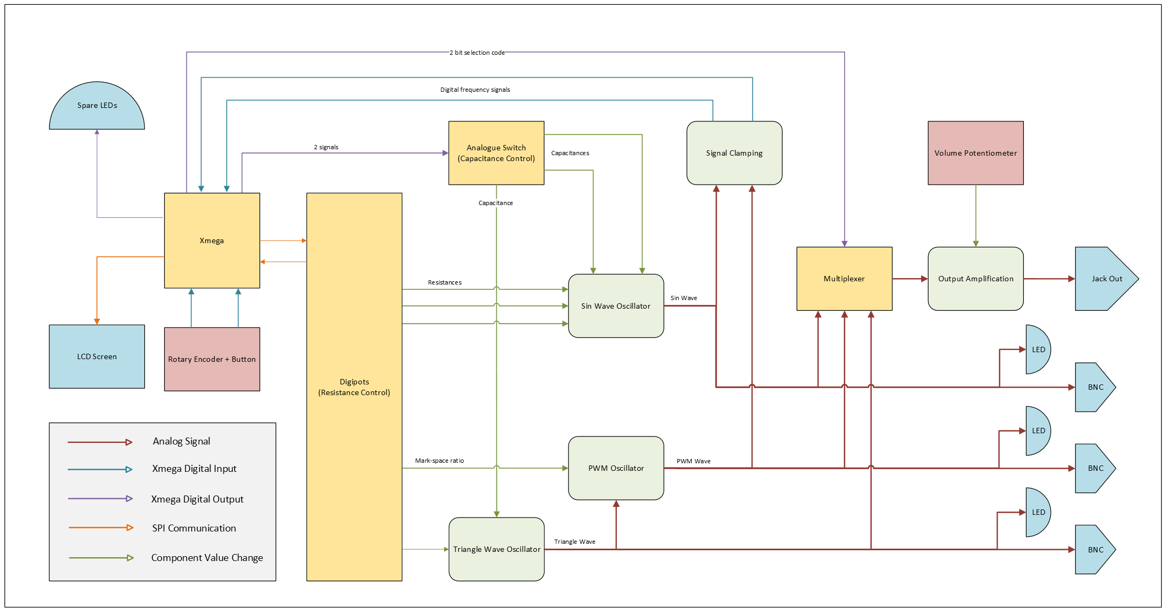
Figure 1 - System Block Diagram
The core of the module revolves around the oscillator circuitry which is controlled digitally by the Xmega. User inputs consist of a 24-detent rotary encoder; a volume control potentiometer; and the 4 existing buttons present on the Xmega development board. The module has three individual BNC outputs paired with corresponding LEDs for signal visualisation, as well as one main audio jack for signal outs. The module also has full control of the LCD screen as well as some spare LEDs for any extra functionality required.

Analogue Outputs
The three analogue outputs are triangle, PWM and sin waves, each operable within a frequency range of roughly 35 - 3500Hz. The three signals are each directly accessible via the BNC output connectors and have been designed to operate at ±10V.

The wave signals also feed into a multiplexer where one can be selected at a time to be the audio output via a 3.5mm jack. This stage is designed to attenuate the chosen signal down to a maximum amplitude of 1.4V (1V_{RMS}) and remove any DC bias from the signal for compatibility with further audio drivers. The volume potentiometer allows further control of the signal’s amplitude from the maximum of 1.4V down to 0V.

Theory of Operation
Within the module there are two oscillator cores that are controlled separately, the first generates both the triangle and the PWM signal while the second generates the sin wave. Each oscillator has its frequency controlled by digital potentiometers which range from 0 – 97.5kΩ [Table 4 in datasheet], as well as two selections of capacitance (10nF & 110nF) which creates two “bands” of available frequencies with some overlap between them.

Triangle and PWM Signals
A triangle wave is generated by charging and discharging a capacitor continuously with a constant current. By varying the current flow to the capacitor, the rate at which it charges and discharges is affected directly. As the capacitance is always going between two known constant voltage levels – the rate of charge is proportional to the period of the signal. The derivation is shown in Appendix A and the symbolic equation comes out to be
$$f_{TRI}=\frac{1}{4HRC}$$
Where $H$ is defined as the ratio of resistors around the comparator. In the case of this module these two resistors are 36kΩ and 39kΩ. There is also a series resistance of 4300Ω in the feedback and so the final equation with $4∙H=4∙\frac{36}{39}≈3.7$ is
$$f_{TRI}=\frac{1}{3.7∙\left(4300+R\right)∙C}$$
The PWM signal is generated from comparing the triangle wave output to a controlled voltage level. Raising and lowering the voltage will alter the duty cycle of the signal. In theory the equation for the Duty cycle, $D_{cyc}$ is
$$D_{cyc}=\frac{10V-V_{ref}}{20}$$
Instructions on setting $V_{ref}$ are detailed in section 3.2.
As the DC bias is removed from the main output signal – at this stage the PWM signal’s duty cycles will appear equal with opposite values e.g. 25% and 75% will sound the same. The BNC connections are not affected by this.

Sin Wave Signal
The sin wave is generated using a Wien bridge oscillator. It uses a network of resistors and capacitors in an arrangement like Figure 2 which acts as a band pass filter to select a calculated frequency.
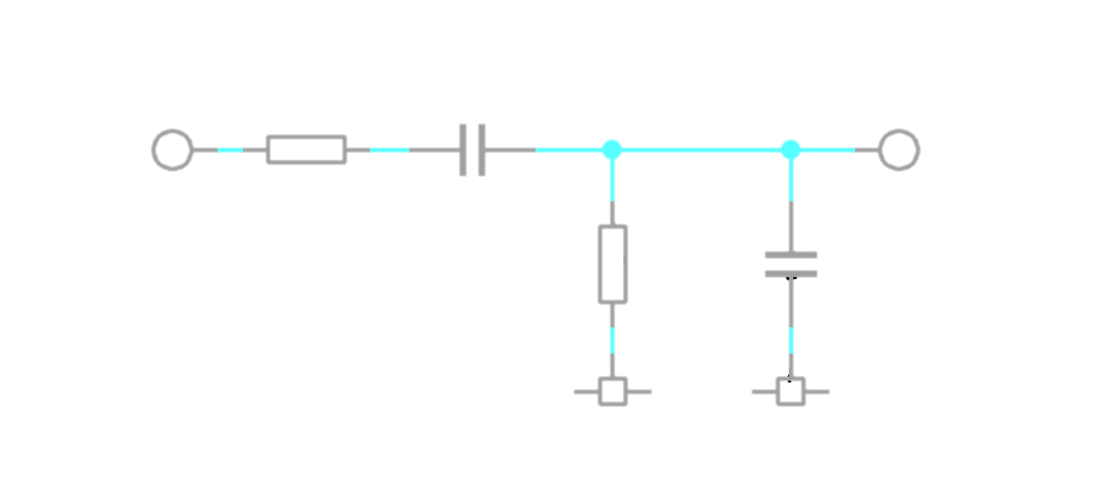
R₁
V_{in}
C₁
R₂
C₂
V_{out}
GND
GND
Figure 2 – Wien bridge network
According to the reactance of a capacitance
$$χ_{C}=\frac{1}{2πfC}$$
At low frequencies, the reactance of the capacitors is very large and so $C_{1}$ blocks the input and the output voltage is 0V. At high frequencies the reactance approaches zero and so $C_{2}$ shorts to ground also pulling the output to 0V. Assuming that the values of the resistors and capacitors are the same in each branch, somewhere in the middle of the frequency range must lie a frequency point which is attenuated the least. Feedback amplification is built around the filter network such that random noise signals will start the oscillation, and the selected frequency will dominate the resultant signal.
The derivation of the frequency equation is shown in Appendix B and comes out to be
$$f=\frac{1}{2π\sqrt{R_{1}R_{2}C_{1}C_{2}}}$$
In this module, the two capacitor values must always be equal, and it is assumed that the resistances are to be set to equal values too. However, this can be adjusted to increase the bandwidth. With these assumptions and the addition of a 1200Ω series bias resistance, the working frequency equation is
$$f=\frac{1}{2π∙\left(1200+R\right)∙C}$$
The Wien bridge oscillator also requires fine gain control. Theoretically there must be a minimum gain of 3 for the circuit to continue oscillating as shown in Appendix B - but in practice it must be slightly more than 3 due to signal losses. Too much gain will quickly start to distort the signal and so careful control of finding the minimum value possible for the circuit to remain oscillating is required. This additional gain is also controlled by a separate resistance network where on this board the gain, β is
$$β≈1+\frac{R+4.7k}{10k}$$

Operational Overview
The board needs to be supplied with +17-24V to function. This can be done either via the DC plug or the terminal block located next to it. Only one of these options should be used at a time.

As discussed above, the frequencies of the oscillator cores both rely on a variable resistance value. This module includes digital potentiometers in place of all resistance values R in described equations. Each oscillator also has two capacitor modes, allowing the user to flip between a 10nF and 110nF capacitances. This essentially creates two frequency bands, a higher and lower, that can both extend the full range of the varying resistance.

From a target frequency, a frequency band can be selected and then a resistance value estimated using the above equations. The outputs of the oscillators are clamped and fed back into the Xmega so the actual frequency can be measured. Using this, the resistance value can be updated in real time until the measured frequency matches the target frequency.

Difficulty arises when choosing a capacitance around the crossover point of the frequency bands.
Figure 3 shows the idealistic relationship between the resistance of the Digipots and resultant frequency of the sin wave Wien oscillator. Navigating the overlap between the frequency bands is a challenge and care should be taken to avoid repeated flipping of the capacitance. It should be noted that the higher band (C=10nF) is generally preferred as there is more resolution per step change within this period, but more complicated switching mechanics involving hysteresis is advised. Appendix E shows more accurate estimations of frequency on log graphs.

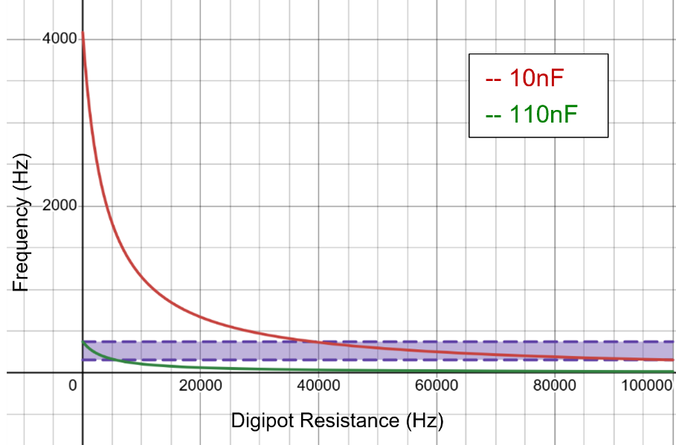
Figure 3 - Graph showing crossover region of frequency bands

Interfacing Guide

Capacitance Selection
By default, all oscillators are in the upper frequency (C=10nF). However, each oscillator has extra 100nF capacitors through an analogue switch in parallel with the 10nF. Providing the pins for capacitor selection with a logic HIGH will enable the additional capacitance and bring the total to 110nF. Both oscillator cores have their own capacitor selection pin so they can be controlled individually.

Digipot Interface
The digipots communicate with the Xmega with an SPI bus. There are TX, RX, CLK, SYNC and RDY pins assigned. On this module, the digipots are configured in daisy chain mode. This means that the Xmega has its TX pin connected to the Data In of one Digipot, and then the Data Out of the first pot is connected to the Data In of the next. Therefore, in order to update the value of one Digipot – you will need to update the values of all Digipots simultaneously. The order of the daisy chain is described in Figure 4 and Table 1.
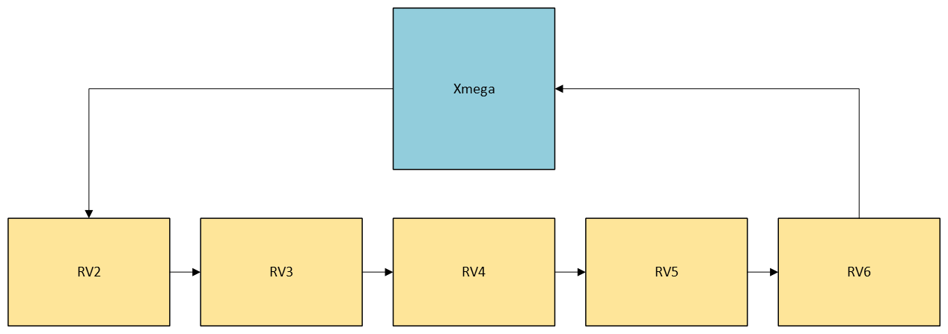
Figure 4 - Digipot daisy chain
Because the signals are propagated through each of the Digipots, the commands should be sent in reverse order (RV6, RV5, RV4 etc…) such that they each arrive at the intended Digipot once the full command string is complete.
Table 1 - Digipot descriptions
Digipot | Max Value ($R_{AB}$) | Description
RV2 | 20kΩ | Gain control resistance of Wien Oscillator
RV3 | 100kΩ | The high pass filter control resistance of the Wien oscillator
RV4 | 100kΩ | The low pass filter control resistance of the Wien oscillator
RV5 | 100kΩ | The frequency control resistance of the triangle oscillator
RV6 | 100kΩ | The resistance controlling the mark-space ratio of the PWM signal

The SYNC and RDY pins on all Digipots are tied together respectively and connected to one pin each of the Xmega. As detailed in the Digipots’ datasheet, the SYNC pin must be held low while the data is clocked through all 5 Digipots and then released only after it has all been sent. As the RDY outputs are also tied together, reading the level of the RDY pin will give limited information about all of the pots simultaneously. The use of the RDY pin is optional and only required to accommodate tighter timings allowing for an increased rate of commands sent to the Digipots.
Another important note is the initialisation of the Digipots. A control bit must be written to the control register in order for the subsequent data commands to actually update the wiper position. Without this, the Digipots will be locked to 50% of their max value. Optionally, in daisy chain mode, the Digipots’ data out pins can be put into high impedance mode to reduce power consumption.
The datasheet [X:/DataSheetsAndImages/PDFs/Resistors/AD5293-AnalogDevice.pdf] includes additional information and detailed instructions regarding commands to send and setup instructions.

Digipots RV2-5 are wired such that the functional resistances are between the A and W terminals of each Digipot. The equation for resistance between the A and W terminals is
$$R_{AW}=\frac{1024-D}{1024}×R_{AB}$$
Where $D$ is the decimal equivalent of the binary code sent to the Digipot register and $R_{AB}$ is the maximum resistance of the Digipot.
Digipot RV6 is used for the mark-space ratio for the PWM signal by generating a reference voltage $V_{ref}$ between ±12V. There are some 22kΩ offset resistors between the rails as shown in Figure 5.
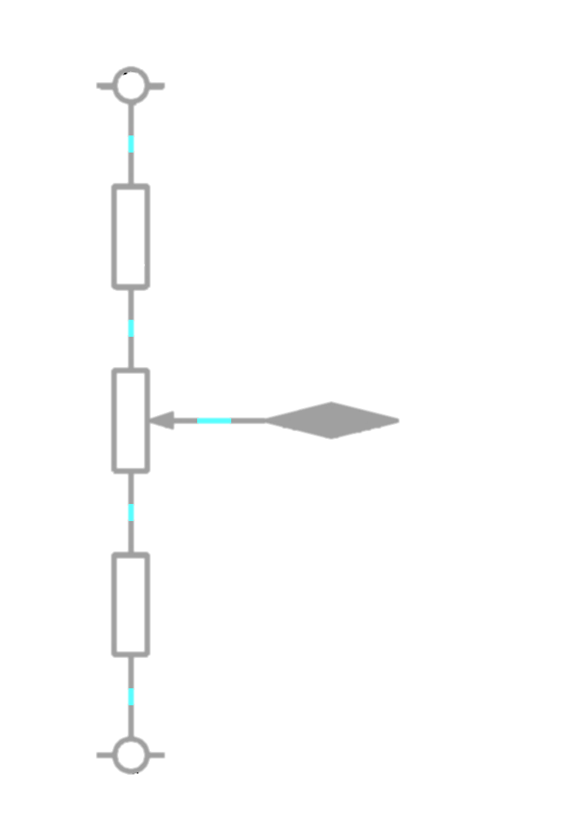
22kΩ
22kΩ
100kΩ
+12V
-12V
Figure 5 - PWM Reference Divider
The equation for the reference voltage is therefore
$$V_{ref}=24×\frac{22k+R_{WB}}{22k+22k+R_{AB}}-12$$
$$R_{WB}=\frac{D}{1024}×R_{AB}$$
$$∴V_{ref}=24×\frac{22k+\frac{D}{1024}∙100k}{144k}-12$$
Alternatively, $\frac{D}{1024}$ can be thought of as just the ratio between the min and max values. E.g. A symmetrical square wave can be generated by writing $D=512$.
The Digipot communication lines are connected to the default USARTC0 bus lines on the Xmega for simple setup and transmission/receiving of data – refer to the Xmega specific guides for this setup.

Frequency Measuring
The outputs of the oscillator cores are each directly fed back into the Xmega via some clamping diodes into two separate pins. The diodes ensure the ±10V signals are truncated down to a range of 0 - 3.3V to protect the Xmega inputs as shown in Figure 6. This also ensures use of the largest $\frac{dV}{dt}$ section of the sin wave for better sensing on the input. The PWM signal is also clamped down to the same range but as it is already rectangular pulses, the shape is not changed.
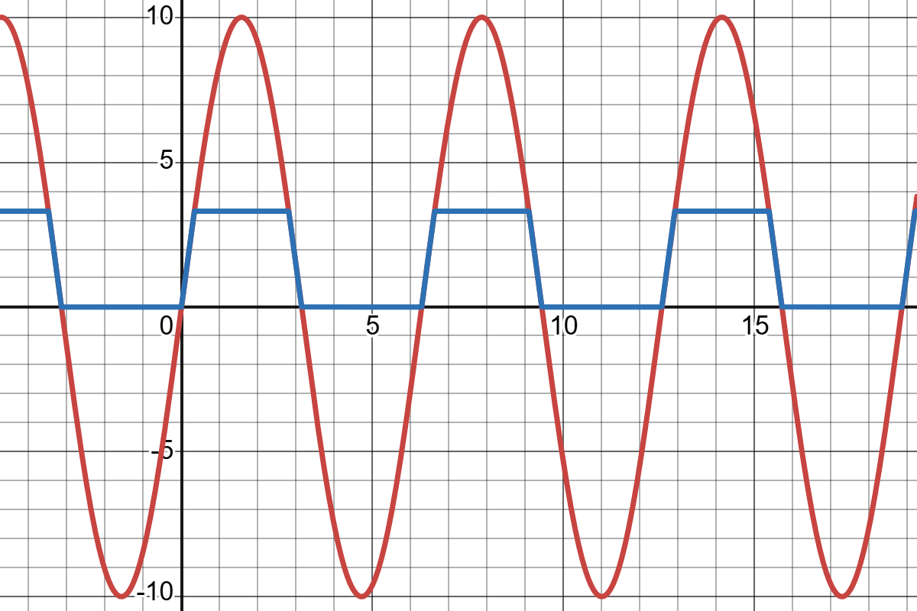
Figure 6 - Clamping Signal Plot
The method of measuring frequency is to be determined by the user, but it may be worthwhile looking into the Xmega event system for a more refined approach.

Rotary Encoder Interface
The board includes a mechanical rotary encoder intended to be used as the primary user interface and input into the system. It includes two terminals for a quadrature signal and one for a push switch. While the Xmega comes packaged with quadrature decoding hardware, the pin setup from the encoder is not laid out to make use of it and such a decoding system must be written from scratch. The push button on the encoder can be treated as a standard active LOW switch.
If the filtering capacitors are fitted on the board, then the three inputs should be naturally debounced, otherwise bounce filtering should be handled in software.

Multiplexer Interface
The multiplexer takes a 2-bit binary code to select between the 3 signal waveforms. The fourth combination output is tied to GND allowing quick disabling of the main output or silent periods without disabling any ICs. The signal selection codes are shown in Table 2.
Table 2 – Multiplexer selection codes
Code | MUX_SEL_1 | MUX_SEL_0 | Output
00 | 0 | 0 | PWM
01 | 0 | 1 | TRIANGLE
10 | 1 | 0 | SIN
11 | 1 | 1 | GND

Extra functionality
There are a few extra features on the board including a spare analogue switch and some extra LEDs that can be used or ignored depending on specific design requirements. The switch is open on both sides and routed to empty pads to connect to any external circuitry. The LEDs are active LOW. There is also a spare op amp, routed in the negative feedback configuration with empty pads on inputs and outputs and space for resistors. The connection points are routed according to Figure 7.
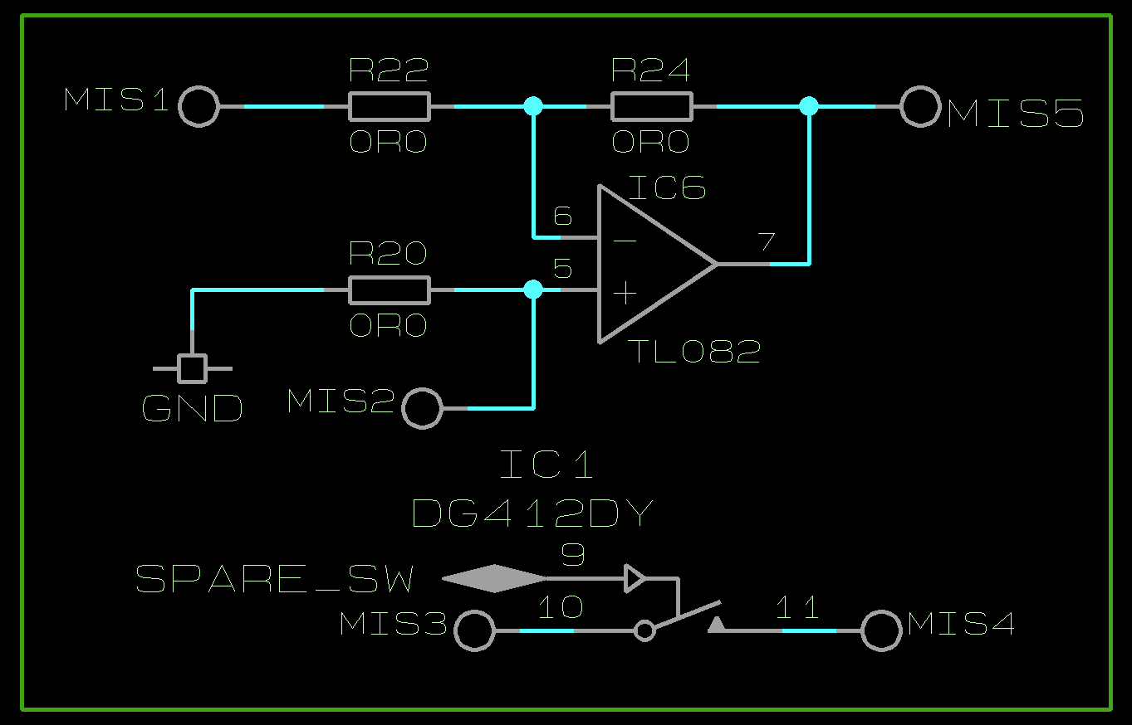
Figure 7 - Spare op amp configuration

Default features
All standard features of the Xmega Xplained board have been kept intact allowing full functionality for existing hardware. This includes the LCD, onboard switches and LEDs, flash memory and all other sensors included on the board, allowing for some interesting possibilities such as temperature-controlled frequency for example. Refer to the Xmega manuals for pinouts and interfacing guides with these standard features.

Pinout & Pin Descriptions
For ease of finding relevant pin information, the pinouts have been organised in terms of their relevant functionality rather than position on the board.

Capacitor Selection Pins
Label | Xmega I/O | Xmega Connector | Signal type | Description
C_SEL_SIN | PB2 | J2.3 | GPIO – OUT | A digital signal to control capacitance selection for Sin wave. LOW for 10nF, HIGH for 110nF
C_SEL_PWM | PA4 | J2.5 | GPIO – OUT | A digital signal to control capacitance selection for Triangle and PWM signals. LOW for 10nF, HIGH for 110nF

Digipot Pins
Table 3 - Xmega Digipot pin list
Label | Xmega I/O | Xmega Connector | Signal type | Description
DIGI_CS | PC0 | J1.1 | GPIO – OUT | The CHIP SELECT or SYNC pin used to initialise and confirm a data transmission with the Digipots. Must be pulled LOW during transmission and released when completed
DIGI_CLK | PC1 | J1.2 | USART – OUT | The CLOCK pulse output for the SPI connection to the Digipots
DIGI_MISO | PC2 | J1.3 | USART – IN | The MASTER IN pin for the SPI connection to the Digipots
DIGI_MOSI | PC3 | J1.4 | USART – OUT | The MASTER OUT pin for the SPI connection to the Digipots
DIGI_RST | PC4 | J1.5 | GPIO – OUT | The RESET pin for the Digipots. Leave pin as input to automatically tie the Digipot pins HIGH. Otherwise, a hard reset is performed on a LOW to HIGH transition
DIGI_RDY | PC6 | J1.7 | GPIO – IN | The READY pin from the Digipots. Active HIGH signal identifies the completion of a write or read operation to/from the Digipots’ registers

Frequency Measurement Pins
Table 4 - Xmega Frequency pin list
Label | Xmega I/O | Xmega Connector | Signal type | Description
F_SIN | PE0 | J4.1 | GPIO – IN | A clamped version of the sin wave signal directly from the oscillator core ready for edge sensing
F_PWM | PA7 | J2.8 | GPIO – IN | A clamped version of the PWM signal directly from the oscillator core ready for edge sensing

Rotary Encoder Pins
Table 5 - Xmega Encoder pin list
Label | Xmega I/O | Xmega Connector | Signal type | Description
ENC_A | PE1 | J4.2 | GPIO – IN | Quadrature signal A from the rotary encoder (leading for CW)
ENC_B | PE3 | J4.4 | GPIO – IN | Quadrature signal B from the rotary encoder (lagging for CW)
ENC_SW | PE2 | J4.3 | GPIO – IN | Active LOW push button switch on the rotary encoder

Multiplexer Pins
Table 6 = Xmega MUX pin list
Label | Xmega I/O | Xmega Connector | Signal type | Description
MUX_SEL_0 | PB3 | J2.4 | GPIO – OUT | Bit 0 of the binary selection code for the signal multiplexer
MUX_SEL_1 | PB1 | J2.2 | GPIO – OUT | Bit 1 of the binary selection code for the signal multiplexer
Refer to Table 2 for MUX codes.

LCD Pins
Table 7 - Xmega LCD pin list
Label | Xmega I/O | Xmega Connector | Signal type | Description
LCD_CS | PF3 | - | GPIO – OUT | The CHIP SELECT or SYNC pin used to initialise and confirm a data transmission with the LCD. Must be pulled LOW during transmission and released when completed
LCD_A0 | PD0 | J4.5 | GPIO – OUT | The register select pin for the LCD. HIGH for reading/writing the display RAM, LOW for all other purposes
LCD_MOSI | PD3 | J4.6 | USART – OUT | The MASTER OUT pin for the SPI connection to the LCD
LCD_CLK | PD1 | J4.8 | USART – OUT | The CLOCK pulse output for the SPI connection to the LCD
LCD_LIGHT | PE4 | - | GPIO – OUT | The control pin for the backlight on the LCD. HIGH to switch on, LOW for off. Can use a PWM output for varying brightness
LCD_RST | PA3 | J3.4 | GPIO – OUT | The RESET pin for the LCD. Perform a hard reset pulling LOW

Switch Pins
Table 8 - Xmega Switch pin list
Label | Xmega I/O | Xmega Connector | Signal type | Description
SW0 | PE5 | - | GPIO – IN | Mechanical button, active LOW
SW1 | PF1 | - | GPIO – IN | Mechanical button, active LOW
SW2 | PF2 | - | GPIO – IN | Mechanical button, active LOW

Extra Pins
Table 9 - Xmega extras pin list
Label | Xmega I/O | Xmega Connector | Signal type | Description
SPARE_SW | PA5 | J2.6 | GPIO – OUT | A digital signal to control the spare analogue switch on board. LOW = open, HIGH = closed.
DEBUG_1 | PC5 | J1.6 | GPIO | Spare pin for debugging purposes. If DBG LED is fitted: active LOW
DEBUG_2 | PC7 | J1.8 | GPIO | Spare pin for debugging purposes. If DBG LED is fitted: active LOW

Test Points
Detailed in Table 10 is a list of the test points included on the board and what signals they are connected to. Locations of the test points can be found by name on the board or referring to the assembly layout in Appendix C.
Table 10 - Test point list
Test Point | Description
MUX | Direct output of the multiplexer – preamplification
AMP | Amplified output signal – pre-DC bias removal + filtering
JACK | Main output signal to the jack plug
ENC_A | Quadrature signal A from rotary encoder
ENC_B | Quadrature signal B from rotary encoder
+3.3V | Positive 3.3V supply (from Xmega)
CS | Digipot chip select
CLK | Digipot clock signal
MOSI | Digipot data transmission line: DG_MOSI
MISO | Digipot data feedback receive line: DG_MISO
DBG1 | Spare debugging pin: DEBUG_1
DBG2 | Spare debugging pin: DEBUG_2
+16-24V | Main power in from plug or terminals
GND | Board ground
-12V | Negative 12V supply
+12V | Positive 12V supply
+5V | Positive 5V supply

Appendix

Appendix A
Triangle Wave Generator Frequency Calculations
Starting with the equation for charging a capacitor
$$\frac{dV}{dt}=\frac{i}{C}$$
and substituting the saturation voltage of the op amp (as it is this voltage that drives the charging) with the resistance.
$$\frac{dV}{dt}=\frac{V_{sat}}{RC}$$
The peak-to-peak voltage is defined as the difference between an upper and lower threshold. Assuming these thresholds are equal and opposite gives
$$V_{pp}=2∙\frac{R_{n}}{R_{f}}∙V_{sat}=2HV_{sat}$$
The time to complete half a period is found from the time taken to charge the full peak-to-peak
$$\frac{T}{2}=\frac{V_{pp}}{\frac{dV}{dt}}=\frac{2HV_{sat}}{\frac{V_{sat}}{RC}}=2HRC$$
Therefore, full period and frequency are as shown
$$T=4HRC$$
$$f=\frac{1}{T}=\frac{1}{4HRC}$$

Appendix B
Sin Wave Generator Calculations

R₁
V_{in}
C₁
R₂
C₂
V_{out}
GND
GND
The divider network has a transfer function of
$$β\left(ω\right)=\frac{Z_{2}}{Z_{1}+Z_{2}}$$
Where $Z_{1}=R_{1}-jX_{C_{1}}$, and $Z_{2}=R_{2}||-jX_{C_{2}}$
$$Z_{2}=\frac{-jX_{C_{2}}∙R_{2}}{-jX_{C_{2}}+R_{2}}$$
$$Z_{2}=\frac{R_{2}}{1+\frac{R_{2}}{-jX_{C_{2}}}}$$
With $X_{C}=\frac{1}{ωC}$,
$$Z_{1}=R_{1}-\frac{j}{ωC_{1}}$$
$$Z_{2}=\frac{R_{2}}{1+jωR_{2}C_{2}}$$
Therefore,
$$β\left(ω\right)=\frac{\frac{R_{2}}{1+jωR_{2}C_{2}}}{\frac{R_{2}}{1+jωR_{2}C_{2}}+R_{1}-\frac{j}{ωC_{1}}}$$

$$β\left(ω\right)=\frac{R_{2}}{R_{2}\left(1+\frac{C_{2}}{C_{1}}\right)+R_{1}+j\left(ωR_{1}R_{2}C_{2}-\frac{1}{ωC_{1}}\right)}$$

The least attenuated and therefore “selected” frequency is when there is no phase change and so can be found by setting the imaginary portion of the transfer function to 0.
$$ωR_{1}R_{2}C_{2}-\frac{1}{ωC_{1}}=0$$
$$ωR_{1}R_{2}C_{2}=\frac{1}{ωC_{1}}$$
$$ω^{2}=\frac{1}{R_{1}R_{2}C_{1}C_{2}}$$
$$ω=\frac{1}{\sqrt{R_{1}R_{2}C_{1}C_{2}}}$$
As $ω=2πf$
$$f=\frac{1}{2π\sqrt{R_{1}R_{2}C_{1}C_{2}}}$$
The gain of the network is found from the magnitude of the transfer function. From above, we assume that the imaginary part is 0 and so the gain can be found from
$$\left|β\left(ω\right)\right|=\frac{R_{2}}{R_{2}\left(1+\frac{C_{2}}{C_{1}}\right)+R_{1}}$$
Assuming that equal values of components are used
$$\left|β\left(ω\right)\right|=\frac{R}{R\left(1+\frac{C}{C}\right)+R}$$
$$\left|β\left(ω\right)\right|=\frac{R}{3R}=\frac{1}{3}$$
This shows that the amplifier will attenuate the selected frequency by $1/3$ and such extra gain of >3 is required for oscillation.

Appendix C
Assembly Diagram
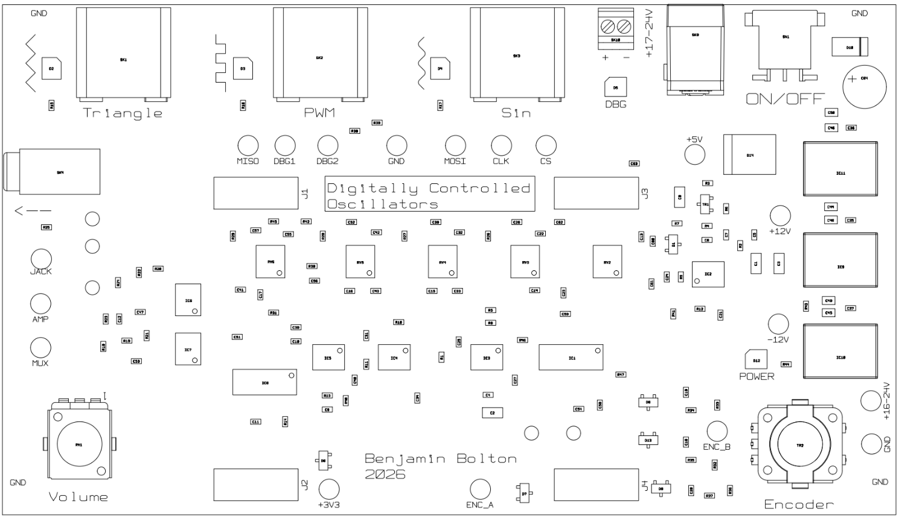

Appendix D
3D Model
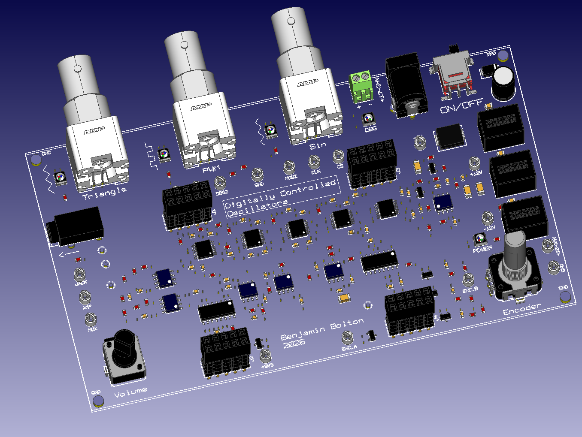

Appendix E
Frequency from resistance of triangle oscillator core
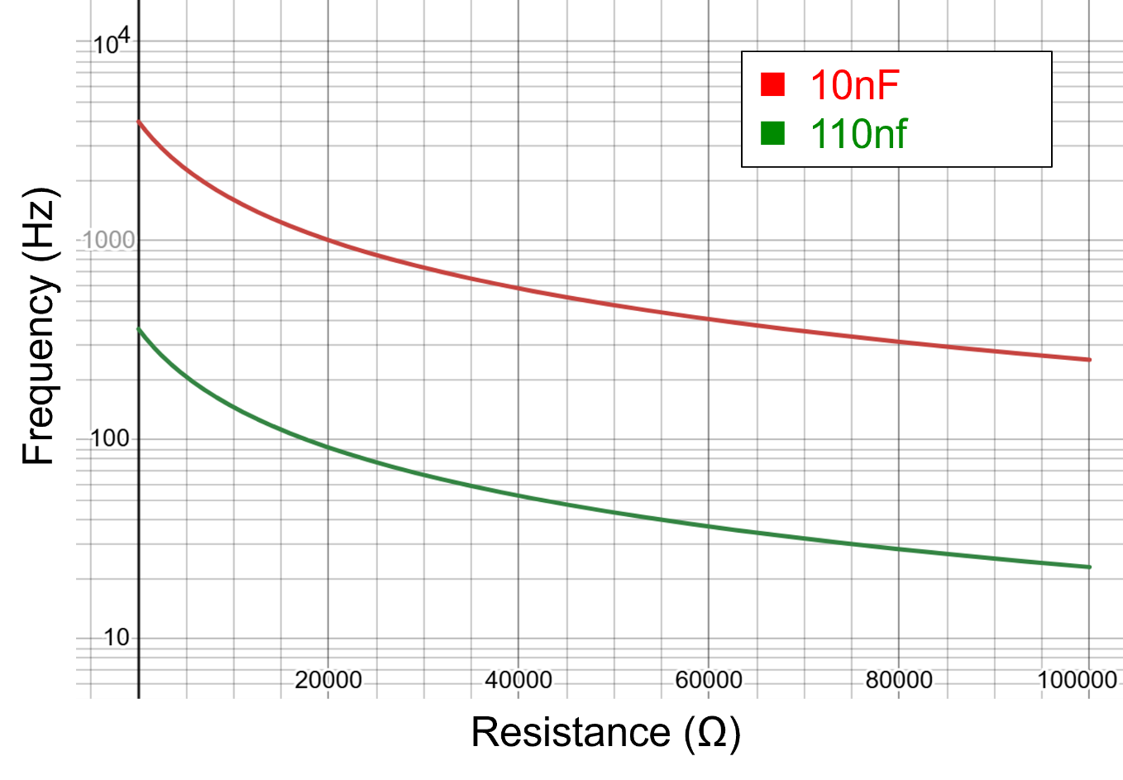

Frequency from resistance of sin wave oscillator core
